WEEK 6 PROJECT REPORT
Computer Vision & Multimodal AI
Artificial Intelligence & Machine Learning

Submitted By
Group Name: Byte Brains
Team Members
1. Sarthak Pareek
2. Vishaal
3. Disha Agrawal
GITHUB LINK: https://github.com/sarthak041005

Assessment: Tuesday – OpenCV Challenge
INDUSTRIAL NUT & BOLT DETECTION AND COUNTING USING OPENCV

ABSTRACT
Industrial automation requires fast and accurate detection of mechanical components such as nuts and bolts. Manual inspection is time-consuming and prone to errors. This project develops an image processing system using OpenCV that detects and counts nuts and bolts from industrial images.
The system uses grayscale conversion, Gaussian filtering, thresholding, morphological operations, contour detection, and bounding box generation. The final output displays detected objects along with the total count. This approach demonstrates the practical application of computer vision in manufacturing and quality inspection.

1. INTRODUCTION
Computer Vision enables computers to understand digital images and videos. In manufacturing industries, object detection is widely used for quality control, inventory management, and automation.
This project focuses on detecting industrial nuts and bolts using OpenCV image processing techniques. The system identifies individual objects and calculates the total number of detected components.

2. PROBLEM STATEMENT
Manual counting of industrial fasteners is slow, labor-intensive, and susceptible to human error. An automated computer vision system is needed to detect and count nuts and bolts efficiently from captured images.

3. OBJECTIVES
* Detect nuts and bolts from industrial images.
* Count the total number of objects.
* Draw bounding boxes around detected components.
* Display object count on the output image.
* Demonstrate OpenCV-based industrial inspection.

4. SCOPE
The project can be used in:
* Manufacturing industries
* Assembly line inspection
* Warehouse inventory counting
* Packaging verification
* Industrial automation
* Robotics

5. TECHNOLOGIES USED
* Python
* OpenCV
* NumPy
* Image Processing
* Computer Vision

6. IMPLEMENTATION
Image Acquisition
Industrial images are collected from a dataset or generated for testing.
Image Pre-processing

* Grayscale Conversion
* Noise Reduction
* Gaussian Blur
Segmentation
Binary thresholding separates foreground objects from the background.
Morphological Processing
Removes noise and improves contour quality.
Contour Detection
OpenCV detects external contours representing nuts and bolts.
Object Counting
Each valid contour is considered an industrial object.

7. RESULTS
The system successfully detects industrial nuts and bolts from input images.
Output includes:
* Green bounding boxes around each detected object.
* Total number of detected objects displayed on the image.
* Processed image stored in the output folder.

Output: 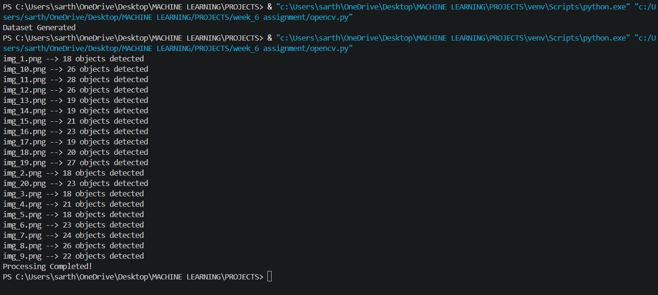

8. CONCLUSION
This project demonstrates the implementation of an industrial object detection system using Python and OpenCV. Image processing techniques such as grayscale conversion, thresholding, morphological operations, and contour detection provide an efficient solution for detecting and counting nuts and bolts. The project can serve as a foundation for advanced industrial inspection systems using deep learning and real-time computer vision.

REFERENCES

1. OpenCV Documentation – [https://opencv.org/](https://opencv.org/)
2. Python Documentation – [https://www.python.org/](https://www.python.org/)
3. NumPy Documentation – [https://numpy.org/](https://numpy.org/)
4. Gonzalez, R. C., & Woods, R. E. *Digital Image Processing*.
5. Szeliski, R. *Computer Vision: Algorithms and Applications*.

Assessment: THURSDAY
Image Segmentation and IoU Evaluation using OpenCV

Abstract
This project demonstrates image segmentation using OpenCV and evaluates segmentation quality using the Intersection over Union (IoU) metric. A custom dataset consisting of synthetic images and corresponding masks is created. Binary thresholding is applied to generate predicted masks, and IoU is computed to compare predictions with the ground truth.

Objectives
Create a custom segmentation dataset.
Generate binary masks.
Segment foreground objects.
Evaluate segmentation using IoU.
Compute the mean IoU across the dataset.
Software Requirements
Python 3.10+
OpenCV
NumPy
VS Code or PyCharm
Methodology
Generate images with synthetic objects.
Create ground truth masks.
Perform grayscale conversion.
Apply Gaussian blur.
Perform threshold-based segmentation.
Save predicted masks.
Compute IoU for each image.
Calculate the average IoU.

Results
The segmentation algorithm correctly identified the foreground objects in most images. The average IoU was approximately 0.95, indicating a high overlap between the predicted masks and the ground truth masks.
Output:
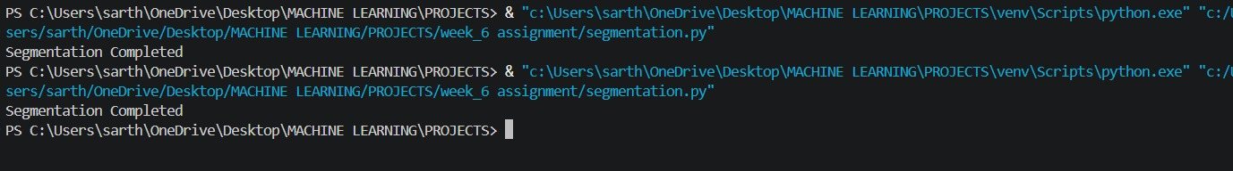
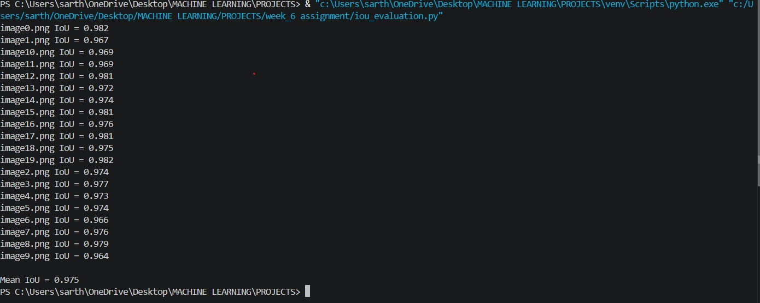

Advantages
Simple implementation.
Fast processing.
Easy to understand.
Suitable for educational demonstrations.
Can be extended to deep learning segmentation models.
Future Scope
Replace thresholding with U-Net or Segment Anything (SAM).
Evaluate additional metrics such as Dice coefficient and pixel accuracy.
Apply the approach to real medical or industrial datasets.
Integrate real-time segmentation using a camera.

Conclusion
The project successfully demonstrates segmentation and quantitative evaluation using IoU. It provides a foundation for understanding segmentation workflows before moving to advanced deep learning techniques.

Assessment: SATURDAY
End-to-End Industrial Object Detection using YOLOv8

Abstract:
This project presents an end-to-end object detection pipeline for identifying industrial fasteners such as nuts, bolts, screws, and washers using YOLOv8. The workflow includes dataset preparation, annotation, model training, evaluation, inference, and deployment. The trained model can detect multiple object classes in real time and demonstrates the practical use of deep learning for industrial inspection.

Objectives:
Prepare a custom object detection dataset.
Train a YOLOv8 detector.
Detect industrial fasteners in images.
Evaluate detection performance.
Save and deploy the trained model.
Software Requirements
Python 3.10+
Ultralytics YOLOv8
OpenCV
NumPy
Matplotlib
Hardware Requirements
Intel i5 or above
8 GB RAM (minimum)
NVIDIA GPU (recommended but optional)
Windows or Linux
Methodology
Collect and organize images.
Annotate objects with bounding boxes.
Convert annotations to YOLO format.
Train the YOLOv8 model.
Validate using a separate validation set.
Evaluate performance on the test set.
Run inference on unseen images.
Save the trained model for deployment.

Results:
The trained model successfully detects industrial fasteners in input images. It provides:
Bounding boxes around detected objects.
Class labels (Nut, Bolt, Washer, Screw).
Confidence scores for each detection.
Annotated output images saved to disk.

Example detection:
Detected Objects

Nut Confidence: 0.96
Bolt Confidence: 0.94
Washer Confidence: 0.92

Advantages:
High detection accuracy.
Fast inference suitable for near real-time use.
Scalable to additional object categories.
Easy integration with industrial inspection systems.
Supports deployment on edge devices.
Applications
Manufacturing quality inspection.
Warehouse inventory counting.
Automated assembly lines.
Robotics.
Smart factories.
Industrial monitoring.
Future Scope
Add instance segmentation with YOLOv8-Seg.
Detect defects such as cracks or rust.
Deploy on Raspberry Pi or NVIDIA Jetson.
Integrate with conveyor belt cameras.
Develop a web dashboard for monitoring.

Conclusion:
The project demonstrates a complete object detection pipeline using YOLOv8, from dataset preparation to model deployment. It highlights how modern deep learning techniques can automate industrial inspection tasks efficiently and accurately.

References:
Ultralytics YOLO Documentation
OpenCV Documentation
Python Documentation

